**Year 8 Source Analysis – Source Page**

**Source 1:** Trial by Combat in Augsburg (c. 9th Century)

*In difficult criminal cases, when ‘ordinary’ evidence was lacking, their legal systems asked God to inform them about defendants’ criminal status. Judicial ordeals took several forms, from dunking the defendant in a pool of holy water to walking him barefoot across burning ashes.*

*Illustration published by Wikimedia in the 21st Century.*

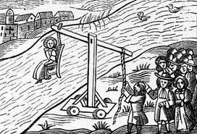

**Source 2:** *A knight promises to be loyal to his king (c. 1390)*

*As part of the Feudal System, Knights often had to declare fealty (loyalty) and offer protection to their kings in exchange for land.*

*Illustration from the 20th Century.*

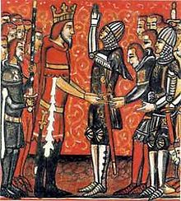

**Source 3:** *Excerpt from Pope Urban II speech (c. 1095)*

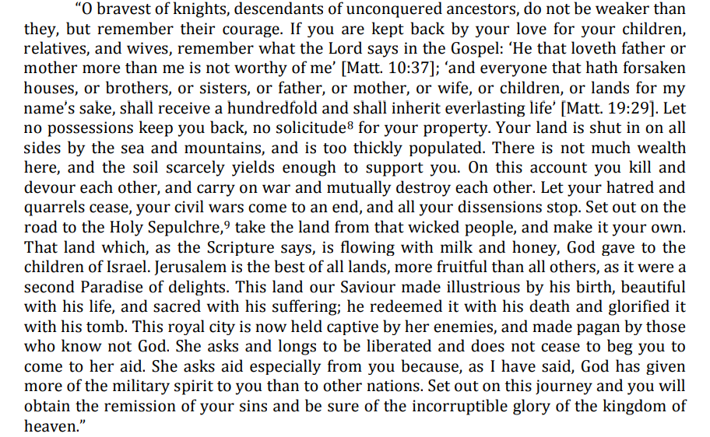*At the council of Clermont (1095), Pope Urban II, at the urging of the Byzantine emperor called for a crusade to wrest the Holy Land—and in particular Jerusalem—from Muslim control.*

**Source 4:** *Image of an original Viking shield stored in the Museum of Denmark (c. 793)*

*The shield was perhaps the most indispensable tool the Viking carried.  The shield was both a defensive and offensive weapon.  Once decorated, it conveyed the user's identity or loyalty, and was sometimes painted with runes or symbols to bring victory.*

